***Make Up Project***

***For Exam***

By: Eric Dockery

Date: 10/25/2013

Programming Project 4.3

Design and implement a class called Car that contains instance data that represents the make, model, and year of the car. Define the Car constructor to initialize these values. Include getter and setter methods for all instance data, and a toString method that returns a one- line description of the car. Create a driver class called CarTest, whose main method instantiates and updates several Car objects.

**How to Solve:**

This is pretty self-explanatory from the problem. First create the Car Class with the private variables make, model, and year of the car. Then I will initialize these values using getMake() setMake() for each of the variables. Then I will make a toString method that prints the values using a return statement. Last I will create the driver class CarTest with a main method that updates several Car objects.

**Screenshots:**

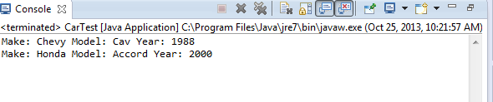

Programming Project 5.9

Design and implement a program that counts the number of integer values in a text input file. Produce a table listing the values you identify as integers from the output file.

**How to Solve:**

For this project the best method of solving would be to use a while loop that will go through until the last instance of the string given. To get each string value you will use a nested for loop that will pull each value of the string and see if it is an integer. I went off the example in the book and used two while scanning loops to find each of the values with a delimiter of (,) separating them. One of the problems I ran into with this that I felt was not really covered in the book is where you place your files to get the new File(“doc.txt”)); I spent about an hour googling where to place this. It may seem very obvious to place it in the workspace folder with the Project to someone with a bit more experience with java, but I was scratching my head for a while.

**Screenshots:**

Doc file

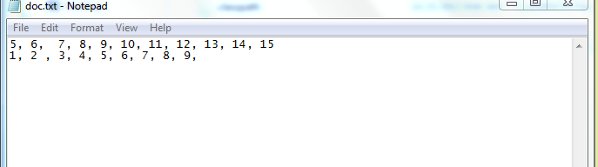

Output

